

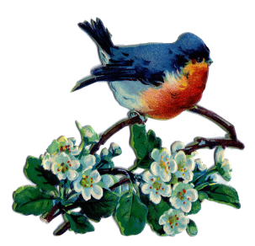**September Good News 2024**

**Our ministry vision for the Virginia Annual Conference is *“to be disciples of Jesus Christ who are lifelong learners, who influence others to serve.”***

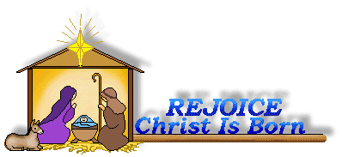

**From Pastor Adam**

**“Fall Colors”**

*The grass withers, the flower fades, but the word of our God will stand forever. (Isaiah 40:8)*

*While the earth remains, seedtime and harvest, cold and heat, summer and winter, day and night, shall not cease. (Genesis 8:22)*

Every now and again I dream about early retirement somewhere tropical, with palm trees and a seemingly endless stream of sunny days. What follows quickly on that thought is the realization of how much I would miss the wonders of Fall. We are most blessed to live in Central Virginia where the weather is temperate, offering rich variety while avoiding extremity. The winters are relatively mild and yet we have just enough snow to make our winter wonderland dreams come true. The summers are generally comfortable, and the fall season is filled with a kaleidoscope of color. We get all the seasons. Just enough of each without too much of one or the other. As the days of summer fade, we see Fall heading our way. The season of pumpkin spice coffee and jack-o-lanterns and warm fuzzy sweaters will soon be upon us. While it has been unseasonably warm recently, I trust that the true “feel” of cooler weather will be here soon. I believe the change of seasons presents us with an opportunity for spiritual reflection – the apparent death of summer foliage sets the stage for the glorious resurrection of Spring. Everything is perfect in its time. The coolness in the air reminds us that even as the world around us changes, the faithfulness,

compassion, and reliability of our God remains steadfast in all things. The changing rhythm of the earth reminds us that God wills this project of the human experience to continue and flourish throughout the passage of time. The arrival of Fall demonstrates the artfulness, majesty, and rationality of the creation and our Creator. May this Fall season bring us new spiritual reflection and vitality. May we enter into a mystery – that as the weather cools, may our hearts grow warm with the love *of* and *for* God and neighbor.

  God bless you my friends, Adam

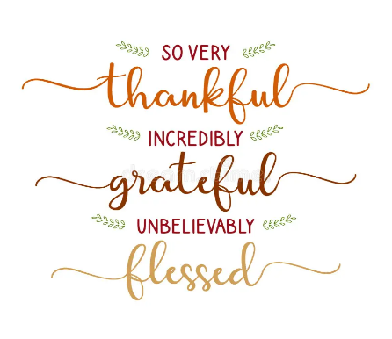

 Circle News

The Wesleyan Group will meet on Monday, September 9th, at 7:00 p.m., at the home of Ann Robbins. We will be taking up an offering for Prayer and Self Denial

*~Ann Robbins*

The Merry Marthas Circle will resume on Thursday, September 26th, 10:30 a.m., at church. We will have our Pledge to Missions Service, making pledges to UWF missions for 2025.

  ~*Judy Robertson*



**The choir** will be singing on Sundays, September 8 & 15. We will be rehearsing at 10:00 a.m. We will sing familiar hymns so please come join us!

*~Heather Wilson*, Director of Music

*Mission Moment*

For the months of July and August the Park View Mission cart contained 28.2 lbs. of food and 128.5 lbs of hygiene products. These items help the mission to meet the needs of our community. Thank you to all who faithfully continue to support this local outreach program. In our small way we do make a difference in our community.

For September we will continue to collect hygiene products as they are always in short supply. We will also collect canned food items with pop-tops to be used in emergency bags. The need

for emergency bags continues to be high.

~*Linda Jessen & Mission Committee*

**Food Cart: September**

Hygiene products: toothpaste, toothbrushes, deodorant, soap, body wash, shampoo. And also canned food items (pop-top). *No* ***“baked goods”****!* *Place donations in the grocery cart, located in the Commons*.

*Save the date…*

You are cordially invited to attend the 90th birthday party for Pat Short on Saturday, September 28 (her birthday is October 1), 2:00-4:00 p.m., here at Chestnut Hill.



Congratulations to Pat Short on the birth of her great-granddaughter, *Eleanor Olivia Hatch,* born to Eden & Eric Hatch, on July 17, 2024. The family resides in Charleston, South Carolina.

Chestnut Hill United Methodist Church *extends Christian love and sympathy to the following:*

To the family of *Carla Musgrove* and especially her children, Brittany and James; her mother, Maggie Musgrove; aunt, Wendy Dalton; and her grandmother, Kathleen Baker. Carla passed away on July 12, 2024.

To the family of *Tammy Vest Balderson*, and especially to her husband, Chris, and son Ryan,

and her mother, Jackie Vest. Tammy passed away on July 1, 2024.

To the family of *Jackie Vest*  and especially to her son-in-law, Ryan Balderson and grandson, Ryan. Jackie was preceded in death by her daughter, Tammy Balderson. Jackie passed away on July 12, 2024.

And to the family of *Donnie Childress* and especially to his wife, Patricia, and children, Heather and Joe. Donnie passed away on July 15, 2024.

To our fellow church family and friends. Chestnut Hill UMC has two (2) cemetery plots. If anyone is planning for a final resting place or knows someone that may be looking, we have two (2) plots at Fort Hill Memorial Park, Lynchburg, VA. These are located in a very sought out area of the memorial park (The Garden of The Good Shepherd). For any questions or if  interested please notify Chet Walker at 434-942-2884 or email to [chumctrustee@gmail.com](mailto:chumctrustee@gmail.com).



I want to thank everyone for their prayers and caring love. I miss you all and will return soon I hope. God is good!

~Love to all Friends, *Gloria & Steve Coleman*

I would like to take this opportunity to thank all of you for your prayers and support along this journey and for the cards, visits, and love shown to me and my family during the passing of our Carla. I would especially like to thank Rev. Adam White, Erin Long, and Vanessa Norman for a wonderful service. Also thank you to the ladies of our church for all the hard work that went into making the reception so special*. “Whenever you feel like you are drowning in life, don’t worry, your lifeguard walks on water.”*

~Love and blessings, *Maggie Musgrove*

*In Memory Of:*

*Carla Musgrove*

Given by: Frances Unruh, Wilton & Kitty Burgess



2024

|  |  |  |  |  |  |  |
| --- | --- | --- | --- | --- | --- | --- |
| ***Sunday*** | ***Monday*** | ***Tuesday*** | ***Wednesday*** | ***Thursday*** | ***Friday*** | ***Saturday*** |
| **1** *15th Sunday after Pentecost*  9:30am Sunday School  10:30am Worship | **2 *Church Office Closed*** | **3** | **4** | **5** | **6**  10:00am Homeschool | **7** |
| **8** *16th Sunday after Pentecost*  9:30am Sunday School  10:00am Choir  10:30am Worship | **9**  7:00pm Wesleyan Group @ Robbins Home | **10**  7:00 pm Homeschool Game Night | **11** | **12** | **13**  10:00am Homeschool | **14** |
| **15** *17th Sunday after Pentecost*  9:30am Sunday School  10:00am Choir  10:30am Worship | **16** | **17** | **18** | **19** | **20**  10:00am Homeschool | **21** |
| **22** *18th Sunday after Pentecost*  9:30am Sunday School  10:30am Worship | **23** | **24** | **25** | **26**  10:30am Merry Martha's | **27**  10:00am Homeschool  4:00pm HS Preteen Game Night  6:30pm HS Teen Social | **28**  2:00 pm  90th Birthday Party-Pat Short |
| **29** *19th Sunday after Pentecost*  9:30am Sunday School  10:30am Worship | **30**  5:00pm Camp Meadowlark Craft |  | | | | |

September Birthdays

4~Jimmy Blunt, Adna Fainter, 5~Shirley Johnson, 8~Monica Campbell, 9 ~Mintcy Maxham,

10~Carolyn Inman, 11~Robert Hicks, 12~Clarissa Clarke, 14~Robert Elium, Jr.,

15 ~Jody Underwood, 18~Robert Bennett, Sarah Stables, 19~Thomas Evans, 21~Naomi Levin,

22~Eleanor Maxham, 23~Mary Walker, 24~Hannah White, 26~Jessah Klein, Sharon Mayhew,

29 ~Beverly Franklin, Chet Walker

**Those Who Serve ~ September**

**GREETERS:**

September 1 ~*Ann Robbins*

September 8 ~*Betty Taylor*

September 15 ~*Jane White*

September 22 ~*Judy Robertson*

September 29 ~*Mary Walker*

**Our Church Financial Picture**

Through the end of July 2024

General Operating Funds:

Needed to meet our 2024 Budget $ 197,677

Needed to meet our budget to date $ 115,312

Actual receipts to date $ 88,948

Shortage to meet budget to date $ 26,364

Actual expenditures to date $ 92,498

Shortage to meet expenses to date $- 3,550

Joy In Missions Funds

Our Giving Goal for 2024 $ 8,600

Needed to meet our goal to date $ 5,017

Actual receipts to date $ 5,790

Special Offerings* (not budgeted):

Received to date $ 5,160

Dispersed to date $ 4 ,830

*Christmas, Easter, Annual Conference,

World Communion, etc.

**2024 Joy In Mission Donations**

To date, the following amounts have

been paid to the missions indicated.

Budget Spent

1. Missionary Covenant Relationship

$1,000 $ 1,000

2. Park View Mission, Food for Families

$3,000 $ 3,390

3. Society of St. Andrew $1,000 $ 1,000

4. Blue Ridge Area Food Bank $1,000 $ 1,000

5. Daily Bread $ 500 $ 250

6. Good Neighbor $ 500 $ 0

7. Habitat for Humanity $ 500 $ 250

8.. UMCOR-Non-Administrative $ 500 $ 0

9. Undesignated $ 600 $ 0

10. Meals on Wheels (Souper Bowl) $ 755

Thank you for your generosity.



1 Pat Short

2 Nancy Lee

Emily V.

Fernandez

3 Michael McGlothlin

6 Kirsten Bell

Tim Crist

Dennis Tolley

7 Kenny Busic

Cheryl Powell

9 Owen Stinnette

Jeremey

VandeBogart

11 Landen Glass

12 Camden Mason

14 Wade Ware

16 Burton Brooks

Terry Palazzi

Anne-Elaine Tiller

17 Suzanne

Marshall

Blake Phillips

18 Sharon

Rickmon

19 Connie Yost

20 Erin Ecklund

21 Steven Kinzer

22 C.O. Bell

25 Frankie

Hardwick

28 Jacqueline Busic

Cheryl Thomas

29 Wes Robbins

Ricky Smith

31 Robert Baunach

**2022**

**March 2022**

**GOOD NEWS** is

published monthly for members and

friends of Chestnut Hill United

Methodist Church. Send articles to

the church office by the 15th of the

month. (Subject to change).

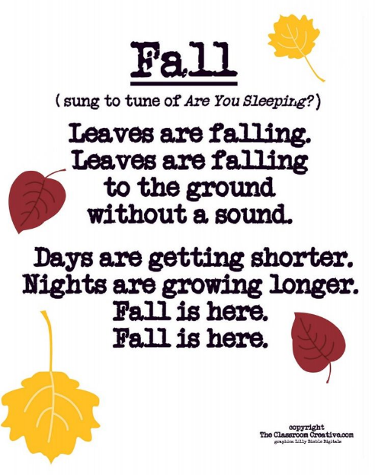



January 2022

**2022**



**April 2022**

**April 2022**

**March 2022**

*Chestnut Hill United*

*Methodist Church*

4660 Fort Avenue, Lynchburg, VA 24502

Phone Number: 434-239-8423: FAX: 434-239-7209

E-mail: [chestnuthillumc@comcast.net](mailto:chestnuthillumc@comcast.net)

On the web: www.chestnuthillumc.net

Church Office Hours

**Monday-Thursday~**9:00 am—3:30 pm

**Friday~**9:00 am-1:00 pm

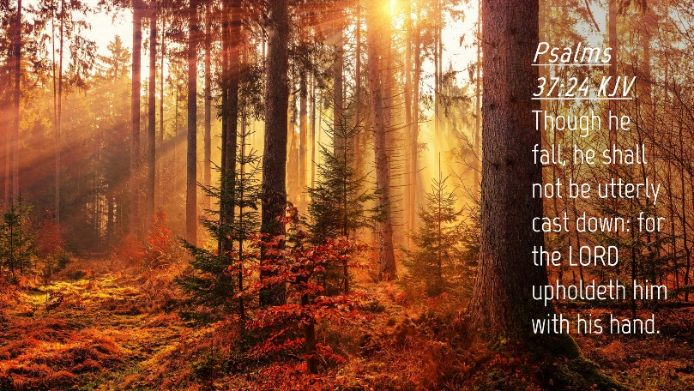

***DIRECTORY OF***

***CHESTNUT HILL UNITED METHODIST CHURCH***

|  |  |  |
| --- | --- | --- |
|  | Sue Haupert-Johnson | Richmond Area Resident Bishop |
|  | Rev. Dr. Sarah Calvert | Mountain View District Superintendent |
|  | Adam White | Minister |
|  | Erin Long | Associate Minister |
|  | Monica Campbell | Administrative Assistant |
|  | Heather Wilson | Director of Music Ministry |
|  | Judy Martin | Bookkeeper |
|  | Judy Robertson | Lay Leader |
|  | Elizabeth Nichols | Missionary in Henry County |